Jon Peterson

WRIT 5662

After reviewing several of the tutorials, I was ready to download DITA and get to work experimenting with the different functions of Oxygen. I followed Kristina’s tutorial and was able to create a DITA project folder.

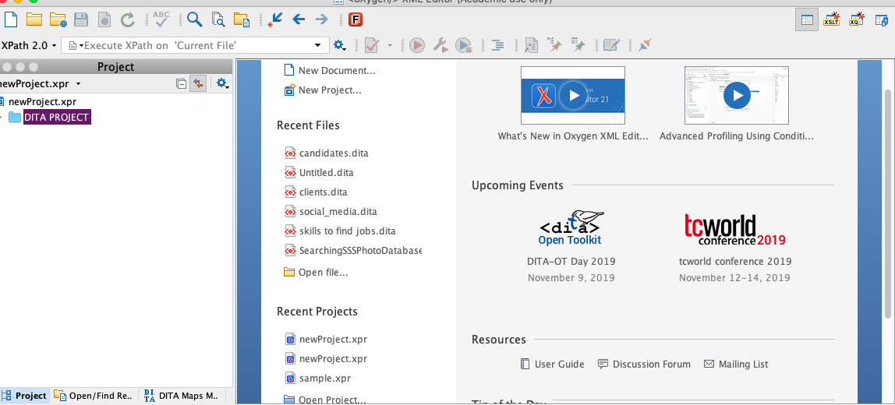

I began creating different categories and painstakingly reviewed Kristina’s tutorial in order to make sure I got every last detail right for my deliverables. I started going back and forth between text and deliverables. For the first time ever, I could more clearly understand the output functionality of the coding as it relates to my desired content.

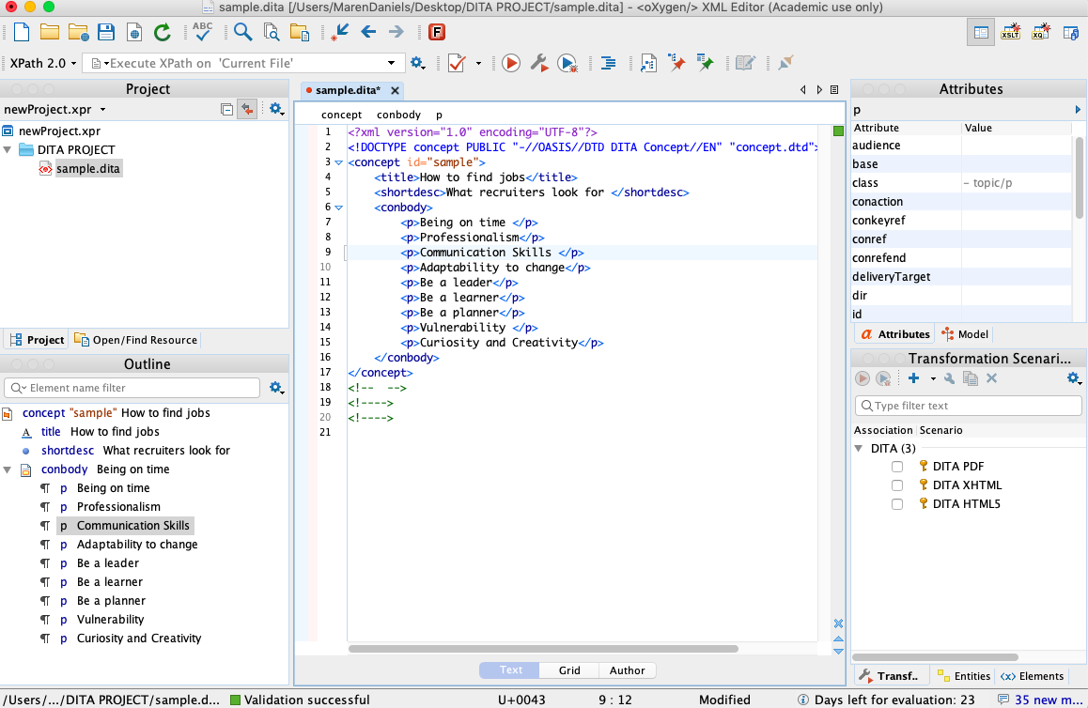

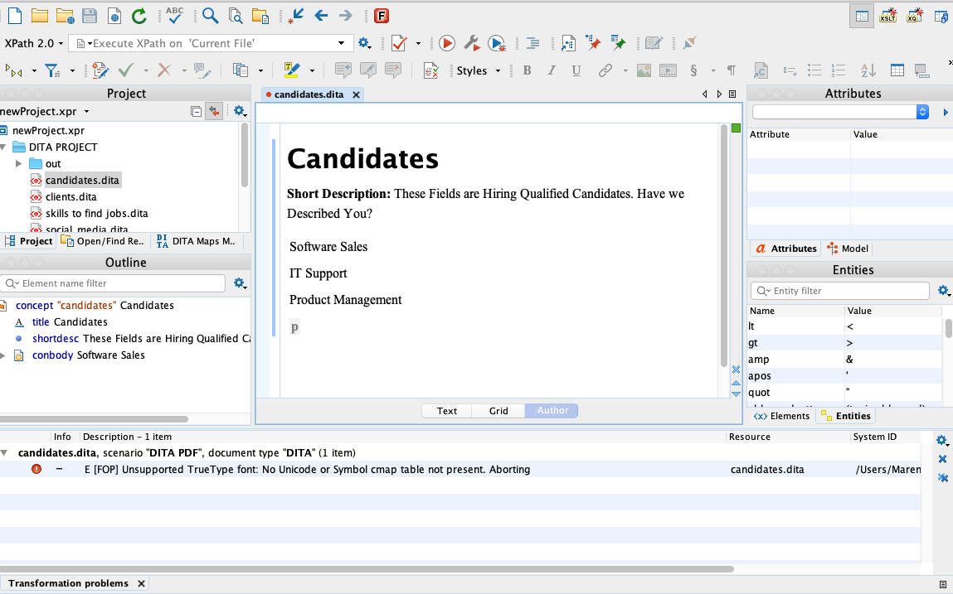

I appreciated the process with which Kristina described how to create a DITA map and the “append child” functions for the mapping component. At first it was challenging because I couldn’t get this function to work but after playing with it I was able to create the properly formatted files. I then validated the various files for submission as PDF and HTML-5

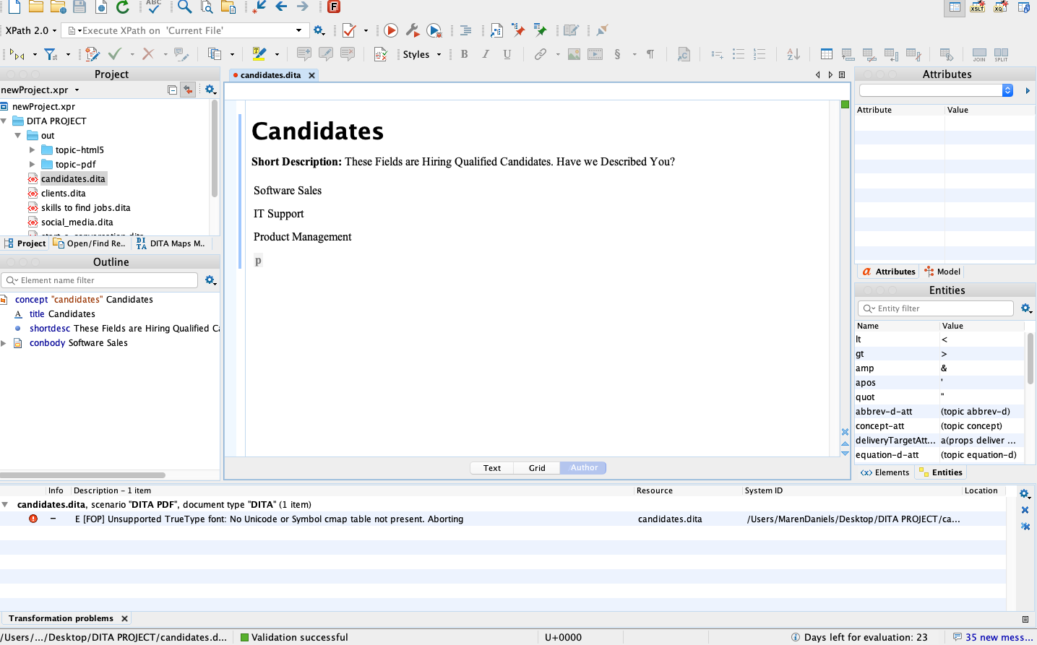

The most useful piece of information was the Bellamy questions paraphrased by a former student and put into a table. I reviewed Caitlin Shirk’s past project and found this information to be an excellent outline for how to frame my information. I kept the same questions but I rephrased them for my project.

| **Question** | **Responses** |
| --- | --- |
| What is the business goal? | The goal is to bring clients and candidates together and to get people jobs |
| What tasks does the user need to perform to accomplish the goal? | The user must be actively engaged in the process of finding information about specific jobs. The site must encourage their ease of use. |
| What are the mental and physical steps required for each task? | The tasks involved are coherently organized and have a simple display |
| Who performs the task? | The job searcher (mainly) |
| When and under what conditions is the task performed? | Generally in between jobs or looking for a new job |
| What are potential distractions to accomplishing the goal? | Too much information or links. We want to keep the user engaged with the site’s purpose. |
| What does the user need to know about the task? | The task of finding companies that are hiring can be daunting. It is best to keep the user focused on making connections and connecting with proper tools to help them succeed. |
| What is the sequence of tasks? | The site is meant to get the user familiar with what Pete’s company can offer and then encourage them to make connections and “start a conversation.” |
| What is the expected result? | The result of this information is to build a link between qualified candidates and hiring managers |
| Guidelines | TBD |
| Check that each topic contains only one type of information. | Each topic is clear and concise |
| Check that each topic is self-contained. | The topics are related but each stand alone |
| Check that topics don’t cover too much information. | The topics are essentialist in nature |
| Ensure that your content is task oriented. | The user is looking for a job or looking for a candidate. This outline is most efficient to help them do so. |
| Do a task analysis to decide what information your topics should contain. | The information contained in each category seems complete |
| Follow minimalist guidelines. | Minimalism is key for my client. |

This table is quite possibly the most helpful aspect of visualizing what DITA can do for UX. For each one of these questions, Oxygen Editor has a great variety of answers. But it is about keeping the project as clear and concise as possible.